Estimation:
Estimation in inferential statistics involves using sample data to estimate unknown population parameters. The goal is to make educated guesses or predictions about the characteristics of a population based on information gathered from a sample.

Point Estimation:
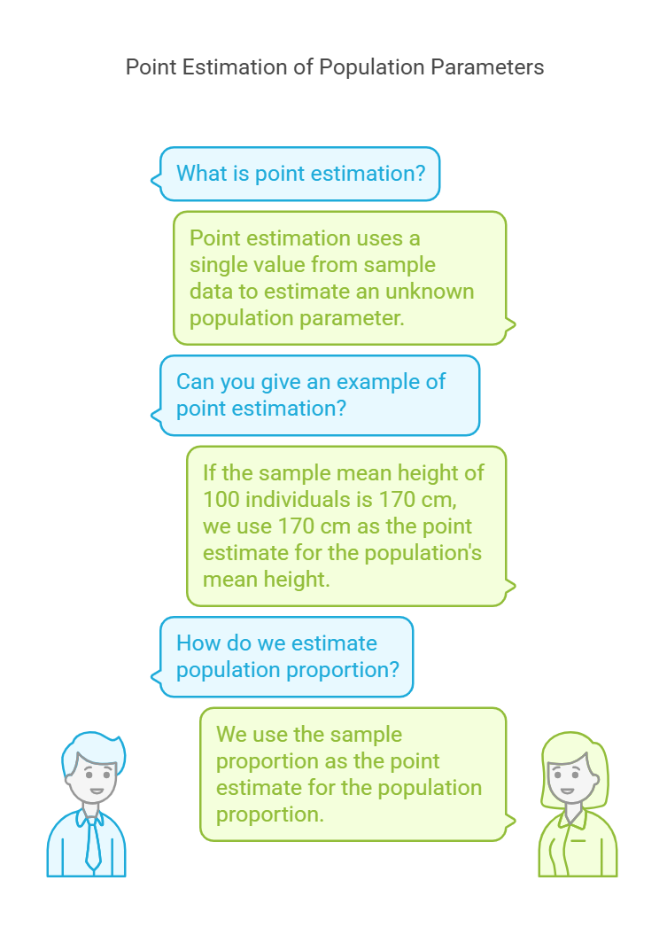

Interval Estimation:
